H3 geospatial indexing was used to identify pollution hotspots within each city. The clustering results, showing PM2.5 vs. other variables (PM10 for NYC, NO2 for Boston), help identify areas with similar pollution characteristics.

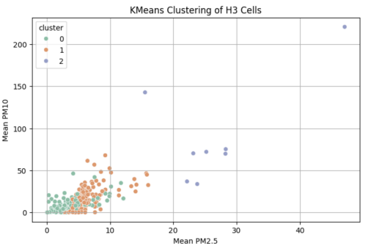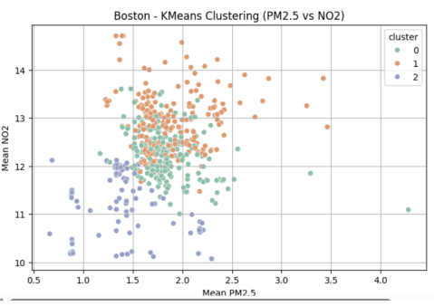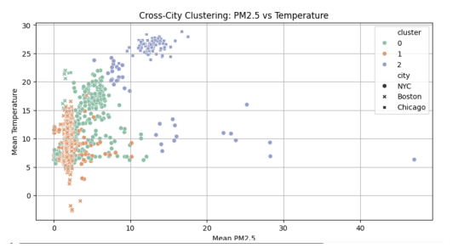

The clustering analyses reveal that each city has distinct pollution zones. In NYC, there’s a cluster with particularly high PM2.5 and PM10 values (cluster 2 with PM2.5 mean of 26.69 µg/m3 and PM10 mean of 90.18 µg/m3 ). These hotspots likely correspond to areas with high traffic congestion or industrial activity.

